So you think you know about WWII?
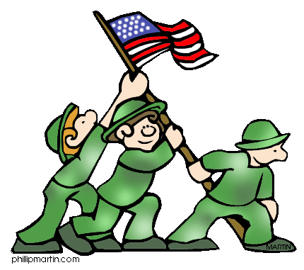
World War II Leaders

Country | Name of Leader(s) | Side Participated On | Type of Government

German, Italian, and Japanese Aggression
 | Steps Taken to Build Dominance | Response by Other Countries
Germany

Area Focused On:
Italy

Area Focused On:
Japan

Area Focused On:

Causes of WWII
- In what ways was war avoided?

- When and why did war eventually break out?

Changing U.S. Role
- How did the U.S. initially respond to the aggression in Europe? Why?

Type of U.S. foreign Policy | What Was It? | Why Did We Use It and When Did We Switch?
Neutrality Acts
Cash and Carry
Lend-Lease
Armed involvement in the war

Key Battles and Turning Points of the War

Theater of War | Key Battle in that Location | Why a Key Battle?

American Homefront During the War
- How were women involved in the war?

- How was the homefront during WWI different than during WWII?

- How did governmental power increase at the expense of Civil Liberties during the war?

- How did propaganda influence the war?

- What kinds of discrimination existed?

World War II Conferences
Name of Conference | World Leaders Participating | Outcome of the Conference

The End of the War
- Did the war all end at once? Explain.

- What happened to the losing countries at the end of the war?

Long Term Effects of the War
- How did world power shift in the years following the year?

- How did borders change following the war?

- Describe the conditions of the affected countries after the war and their focus in the coming years.

